Creating a project by writing a following command:

npm create vite@latest

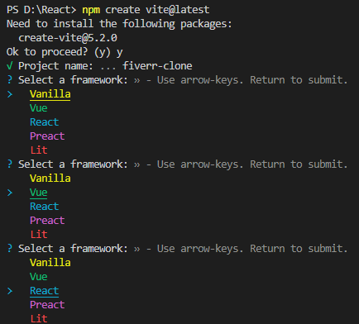

for adding a package in that folder:

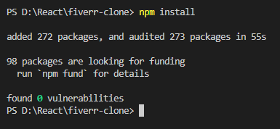

For adding a sass file in your project for using scss(css file):

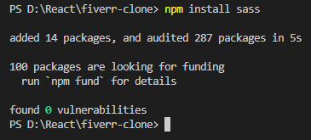

With the help of eslint, find error quickly:

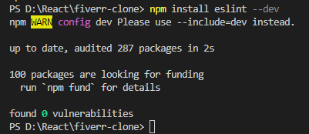

Initialize init a program, after installing it:

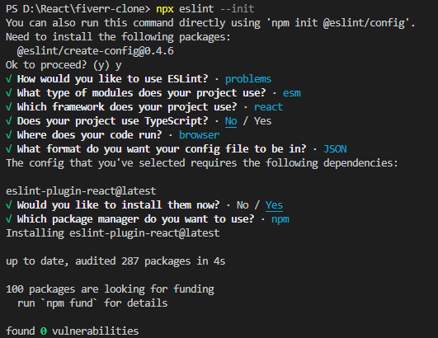

How to run a fiverr project:

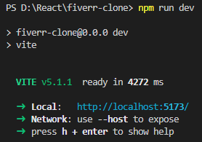

For creating a link install a react router-dom:

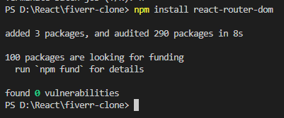

For adding a slider in your project:

